**Addition of another tab (between About us and Membership)**

We are wanting to add a “Deals “page to our website so that business can advertise deals that would be of particular interest to the users of the website.

We would like it have have a similar feel to grabone.co.nz (link below)

<https://new.grabone.co.nz/waikato/automotive?view=grid>

If it could look similar to the below look and feel

As admin we would load the deals (kind of like how we would load the blogs)

There would be a maximum of two ads across the page and Numberous down the page.

If a person clicked on the like they would (see further details)

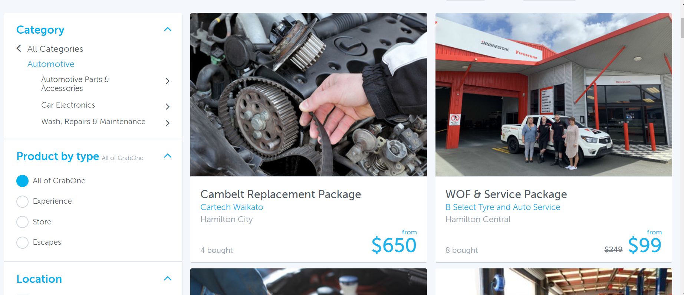

If they clicked on the link they would see (further detail) as below

There would be details about the offer a contact phone number, an email address and link to their website .

